Maximizing Business Success with Microsoft Marketing Tools
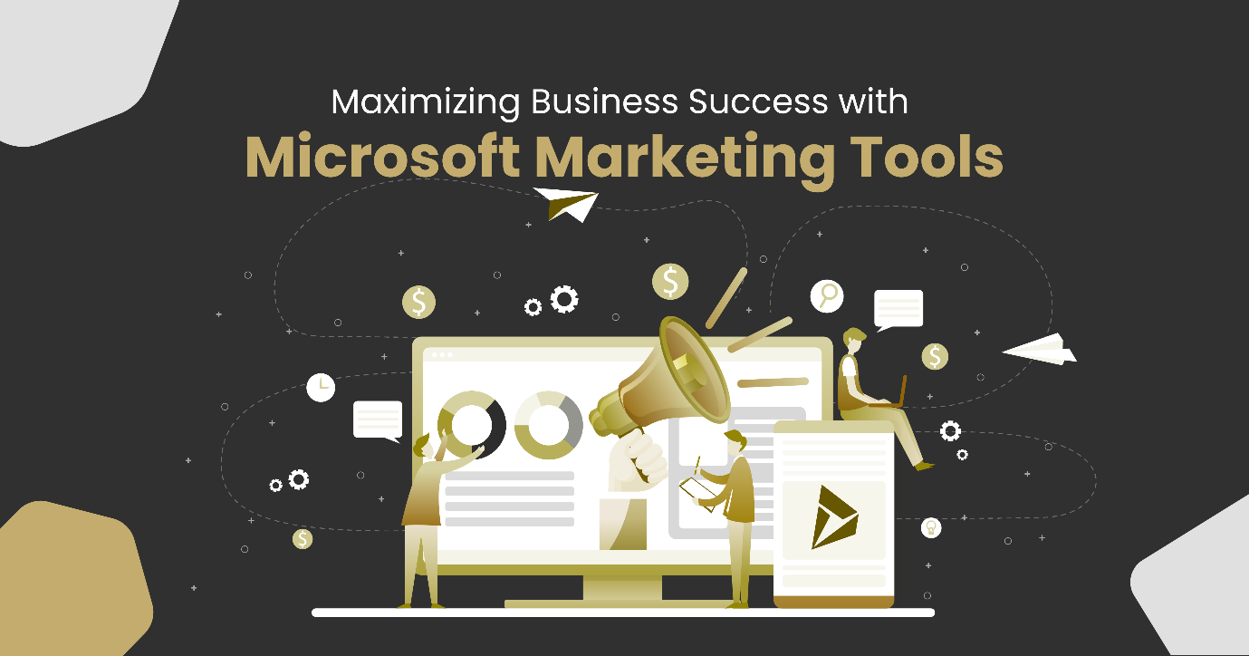
In today's digital age, effective marketing strategies are essential for businesses to thrive and reach their target audience. Microsoft, a technology giant, offers a range of powerful marketing tools designed to help companies to achieve their marketing goals efficiently and effectively. In this blog post, we will explore some of the key marketing tools provided by Microsoft and discuss how they can benefit businesses of all sizes.

What is Microsoft Dynamics 365?
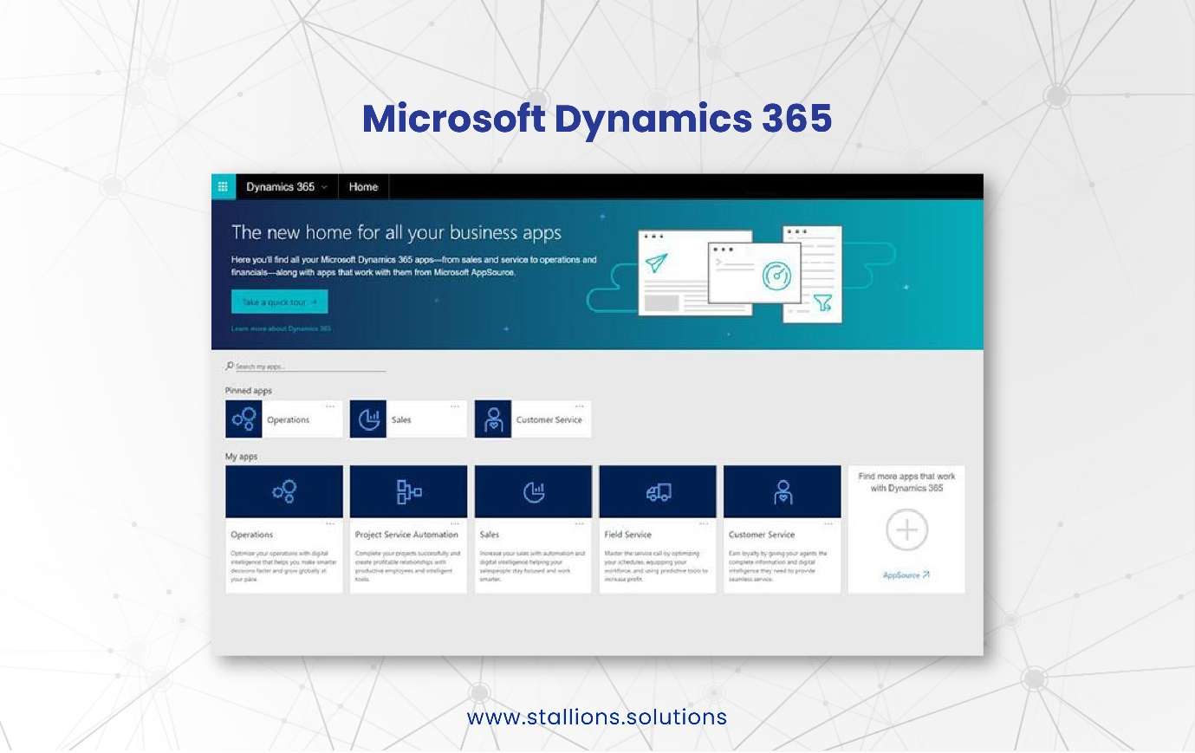
Microsoft Dynamics 365 is a suite of cloud-based business applications that integrates Customer Relationship Management (CRM) and Enterprise Resource Planning (ERP) functionalities. It offers a range of tools and solutions designed to streamline and enhance various aspects of business operations, including marketing.

What is Microsoft Dynamics 365 Marketing?
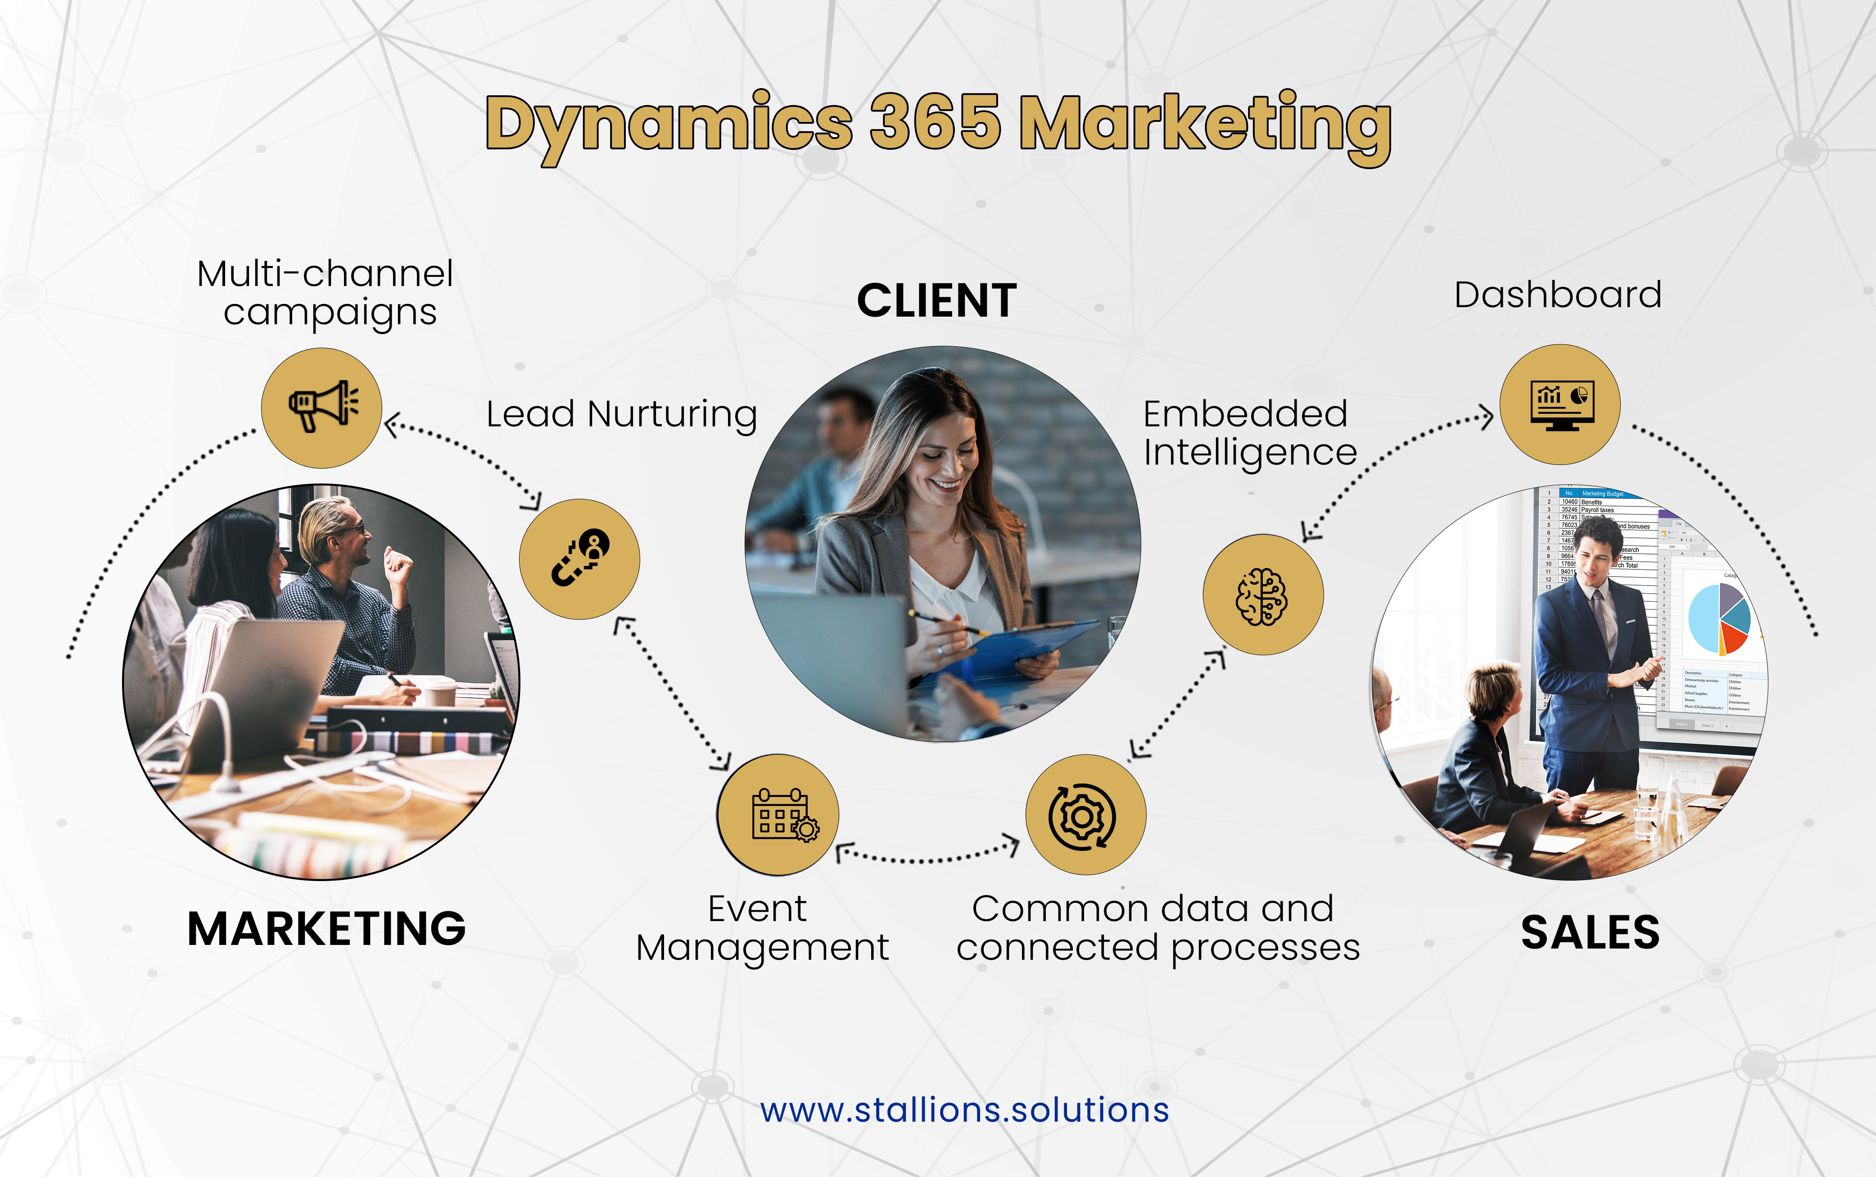
Microsoft Dynamics 365 marketing is an all-in-one marketing automation solution that empowers businesses to streamline their marketing efforts. It offers many features, including lead generation, email marketing, customer segmentation, campaign management, and analytics. With its intuitive interface and seamless integration with other Dynamics 365 applications, marketers can create personalized customer journeys, track engagement metrics, and optimize campaigns for maximum impact.

Within Microsoft Dynamics 365, several marketing tools empower businesses to manage and optimize their marketing efforts effectively.

Microsoft Advertising
Formerly known as Bing Ads, Microsoft Advertising is a powerful advertising platform that allows businesses to reach their target audience across the Microsoft search network. With access to millions of Bing, Yahoo, and AOL users, advertisers can create highly targeted campaigns based on demographics, geographic location, and user intent. Microsoft Advertising also offers robust reporting and analytics tools, allowing marketers to measure campaign performance and make data-driven optimizations.

LinkedIn Marketing Solutions
LinkedIn, the world's largest professional networking platform, is a valuable resource for businesses looking to connect with professionals and promote their products and services. Microsoft, which acquired LinkedIn in 2016, provides a suite of LinkedIn marketing solutions to help businesses maximize their presence on the platform. These solutions include Sponsored Content, Sponsored InMail, and Dynamic Ads, which enable marketers to reach their target audience with personalized messages, drive engagement, and generate leads.

Microsoft Social Engagement

Social media plays a crucial role in modern marketing strategies, and Microsoft social engagement offers a comprehensive solution for monitoring and analyzing social media conversations. Marketers can gain valuable insights into customer opinions, industry trends, and campaign performance by tracking brand mentions, sentiment analysis, and competitive insights. This tool also facilitates social media engagement by enabling businesses to respond to customer inquiries and manage their online reputation effectively.

Microsoft Power BI
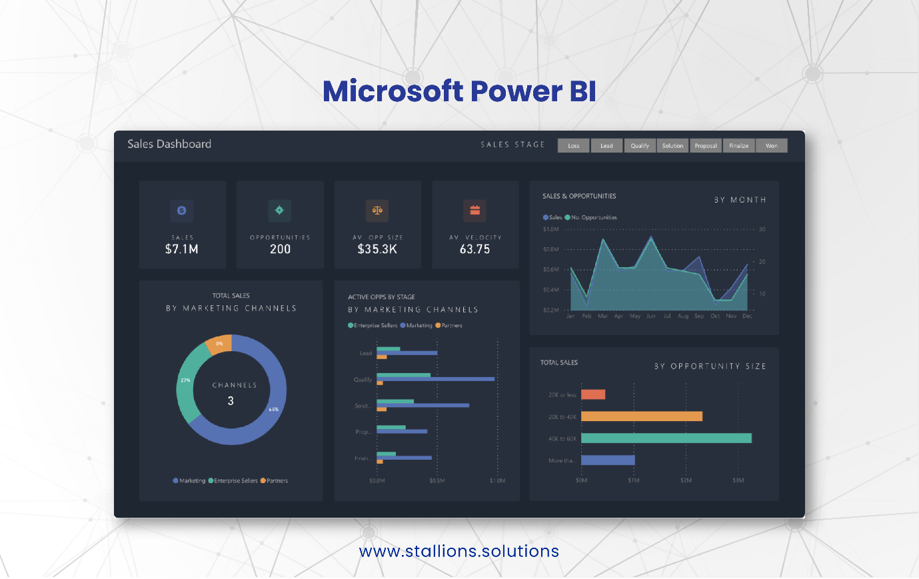
Data-driven decision-making is essential for successful marketing campaigns, and Microsoft Power BI provides a robust business intelligence platform for visualizing and analyzing data. With its intuitive drag-and-drop interface, marketers can create interactive dashboards and reports, combining data from various sources, including Microsoft Dynamics 365, Excel, and other third-party applications. Power BI's advanced analytics capabilities help marketers identify trends, measure campaign ROI, and make data-backed decisions to optimize their marketing strategies.

Microsoft Customer Insights
Understanding customer behavior and preferences is vital for crafting effective marketing campaigns, and Microsoft customer insights help businesses achieve this goal. By combining customer data from multiple sources, including Dynamics 365, Office 365, and third-party systems, marketers can gain a 360-degree view of their customers. This tool provides advanced segmentation capabilities, allowing marketers to create personalized experiences, target specific customer segments, and deliver relevant content across various channels.

Conclusion
Microsoft's suite of marketing tools offers a comprehensive solution for businesses aiming to maximize their marketing efforts. From marketing automation to advertising and social media engagement to data analytics, Microsoft provides powerful tools to help companies to drive customer engagement, generate leads, and achieve marketing success. By leveraging these tools, businesses can streamline their marketing processes, gain valuable insights, and optimize their campaigns for better results. Whether you are a small business or a large enterprise, Microsoft's marketing tools can be a game-changer in achieving your marketing goals in today's digital landscape.

